# LAW iPad Experiment P 2

There are controls at the bottom of the LAW screen. See Figure 1, which is the course browser screen. The following controls should be added to the prototype:

* Show answer: this just shows the correct answer and then "gives up" and moves along.
* Play lecture: this plays the lecture associated with the exercise. I am sending you the lecture files, as MP4. One is for the "nouns" exercises, the other for the "topic sentence" exercises. Figure 2 shows the start of the "nouns" lecture
* Glossary: for right now, just have this come up with a popup that says "The glossary will be here." with a dismiss button. Or leave it blank.
* Omit the little scroll bar and the "exercise" box. These are part of the course browser, not the actual exercise that students see.

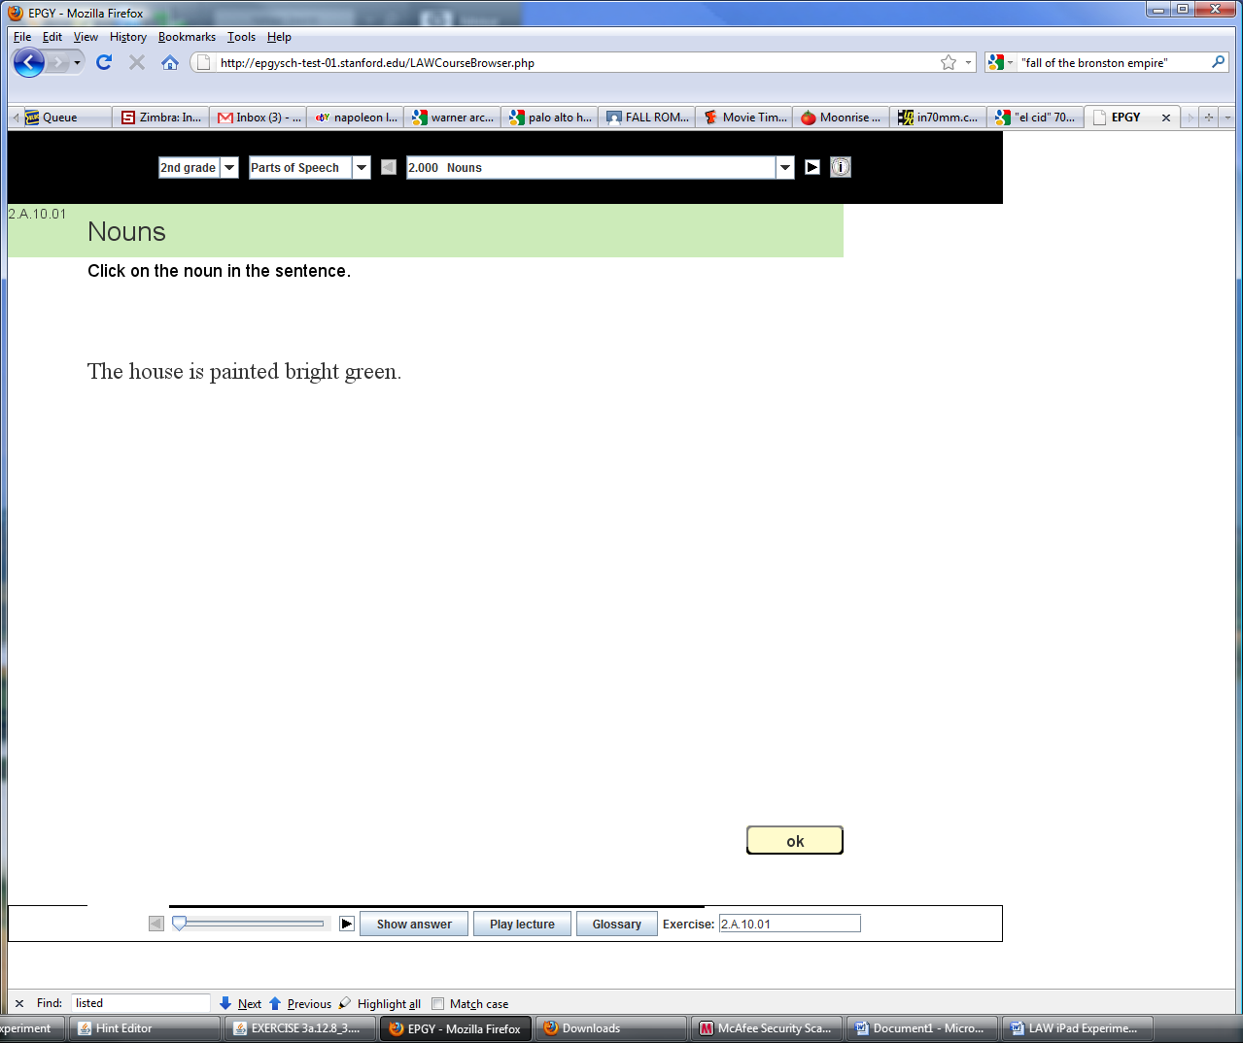

Figure 1: Course Browser Showing Controls at the Bottom

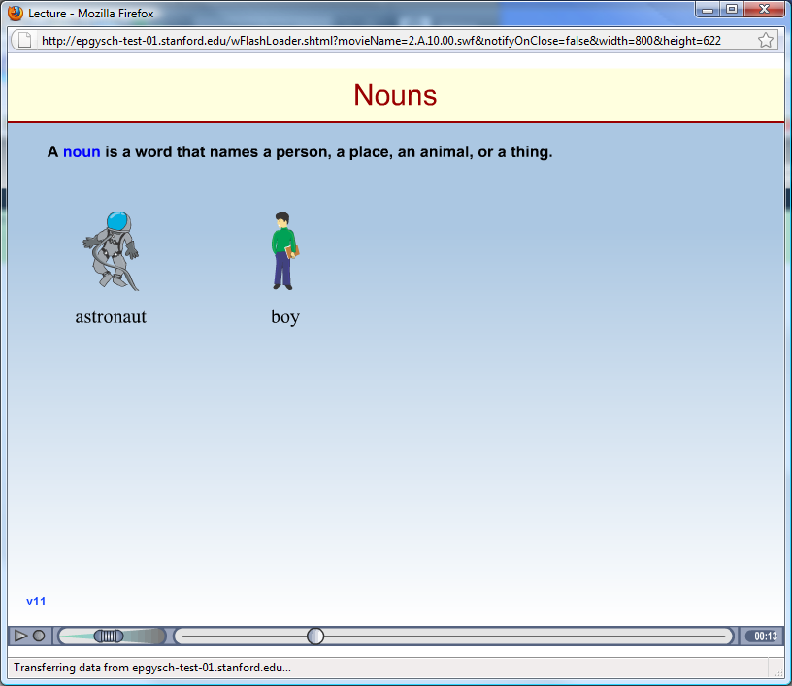

Figure 2: Start of the actual lecture, now an MP4 File

